Final Project Design Phase
Computer Science - Week 11
Oct 3, 2026 - Version 0.0.4

For complete instructions and project ideas, refer to the assignment in Canvas. Specifically, review the final project requirements before you continue below. If you have not reviewed the project requirements in Canvas (you might have to go to the modules view and check the current or past week's content), you will not be able to properly complete the parts below. In addition, it may be helpful to review the information on this Drafter documentation page.

0) Project Planning and Preparation
Successful programmers spend time planning before they begin coding. After reviewing the project requirements, answer the following questions to help guide your design and development process.
- What concepts from class or previous assignments might help you complete this project? Which programming concepts (loops, conditionals, lists, classes, etc.) do you expect to use? What programming skills do you want to improve while completing this project?
I expect to use:
- Dataclasses: Game dataclass
- Conditionals: “If an input is valid…, If date of game X is earlier than date of Game Y…, If Game X has opponent “Mike”..., etc”
- Loops: Filtering and sorting games by some condition (Date,Opponent, Result)
- List: Use Drafter to display a List of all Games in your library.

- Which parts of the project do you expect to be the easiest for you? The hardest? Why?
Easiest: The easiest part will probably be making all the features of a Game (Dataclass, displaying using Drafter, assigning attributes). Almost everything else should also be easy.

Hardest: The hardest part will probably be connecting all the Drafter pages together so they display what I want them to display and all the buttons and other input fields connect to the right page. It will probably be the hardest part because Drafter for me can get confusing on what page connects to what, and how to organize the page to look correct.

- Even though you have not yet designed the final project, estimate which tasks will likely require the most time and effort? Which features or components should be implemented first?
The task that will take the most time is most likely inputting your move and your opponents move, and the page updating to showcase the moves as a numbered list to keep track:
- e5 | e4
- Bc4 | Nc6
- Qxf7# | (no input due to game end)

The feature along with any connecting features with it (editing moves, evaluating if the move notation is possible, saving to a string…) should be implemented first as it will most likely be the most complex and take the longest time.

- What distractions might interfere with your work and how will you minimize them? What resources will you need available while working? What questions, if any, do you still have about the assignment requirements?
Some distractions include looking at my phone or watching tv as I’m working which will decrease my efficiency. I will minimize by working in silence or non-disruptive ambience so I can keep my full attention to my project.

1) Site Diagram
Create a mock-up of your planned website. We suggest you make the mockup on paper, although you can also use software like PowerPoint or Slides to make a mockup. There is other design software that could also be used, but we strongly encourage you to keep it simple. Do not spend more than 15-30 minutes detailing the mock-up. Your goal should be to make a very quick and dirty diagram, to show that you have some kind of idea.

We recommend drawing each page as a rectangle, and laying out the text, buttons, and other components inside. Then, use arrows to indicate links between pages. Label each page the way you will name each function, and then put labels on the arrows to indicate what the button links. Also write down any parameters that should come into the pages.

In addition to the pages and routes, write down what fields your `State` will have, both their names and types. Think clearly about what data will need to be persistent across the entire website.

Add photo(s) or screenshot(s) of your website mock-up and labeled diagram on the next page.

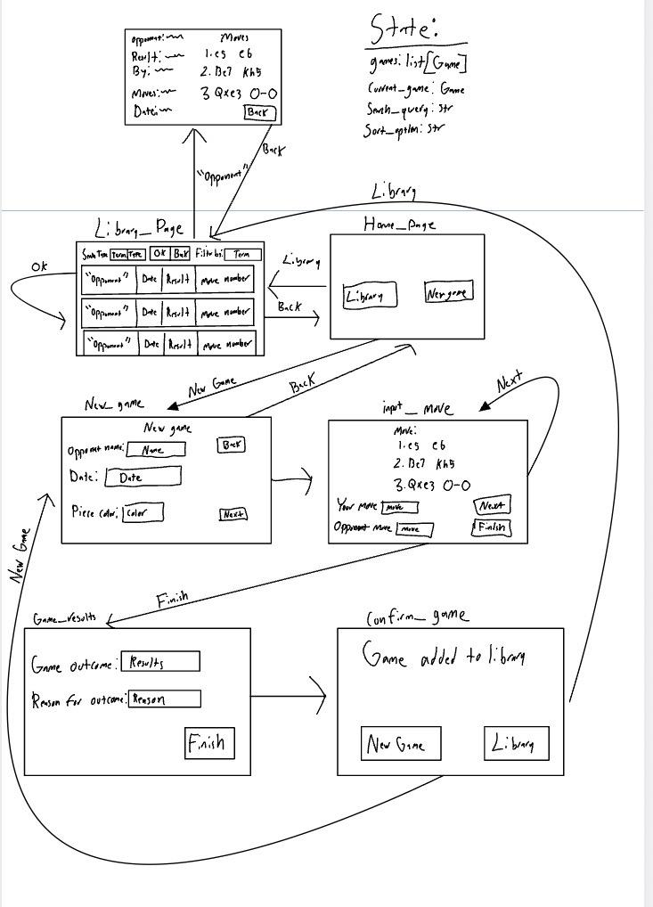
2) Implementing Requirements
This table should serve as a draft for how you will implement the requirements into your final project. You may change your ideas later on, but your final site must fulfill all the requirements.

Requirement | Implementation
Purpose/Functionality  A 1-2 sentence description of the purpose or functionality of your site | My site allows people to record their ongoing chess games by inputting their and their opponents moves and saving them so they can analyze their games afterwards. They can later on open their library and see data about their past games including opponent name, moves, and result of the game.
State Dataclass Attributes  Minimum of 4 attributes, one of which must be a list/dict of instances of your second dataclass.  Briefly describe each attribute, its type, and how it will be meaningfully modified throughout the site. | class: State  - games: list[Game]  - A list of all games added in a collection to display and search through. Every new game you add gets added to this list.  - current_game: Game  - The current game that you editing information about or is selected in your library  - search_query: str  - The search term that you typed in to search games for. “Dave”, “11/24/2026”  - sort_option: str  - The sorting option you selected to display your library in. “Earliest”, “Wins”
Second Dataclass  Your second dataclass, including its attributes, their types, and how they will be meaningfully modified (if they are modified) | Class: Game  - opponent: str  - Name of opponent played against  - moves: list[str]  - List of the moves played in the game "[e4 e5,Bc4 Nc6, Qh5 Nf6, Qxf7#]"  - is_white: bool  - If the users plays as white in this game; else he is playing with black  - result: str  - The result of the game relative to you. “Win”, “Loss”, “Draw”  - result_factor: str  - The exact way you won, lost, or tied a game. “Checkmate, Stalemate, Time”  - date: str  - The date the game was played on. “11/5/2026”
Routes (minimum 7)  The names of your route functions | home_page  library_page  input_move  update_moves  game_data  confirm_game  new_game  game_results  library_statistics
Pages (minimum 5)  A brief description of the pages in your site | I will have a home page that has two buttons: One for the library page and new game page. The library page showcases all of the games with buttons to open a game’s data and a page to look at the statistics for the summation of all games. The new game page will have you add all the information about the game before sending you to a repeating page to add moves until the game ends, in which it adds that game to the library.
User Input (minimum 3)  Description of user input components (TextBox, TextArea, CheckBox, or SelectBox) and their purposes  For more information on these input types, see Drafter Documentation. | - TextBox:  - Typing in information when making a new Game (opponent name, move, ...)  - Typing in a search term when searching your library for a certain game(s)  - CheckBox:  - Select what fields of the Game you want to enter data for in case there are some that you can’t. (Don’t know the name of the opponent or date played)  - SelectBox:  - Selecting the result of a new Game you’re creating (Win,Loss,Draw,Unfinished)  - Selecting the specific reason for the result.(Checkmate, Time limit, Stalemate, Abandoned)  - DateInput:  - Inputting the date a Game occured
If Statements (minimum 3)  Brief description of what will be evaluated in your if statements and how they will meaningfully change the logic of the site | - Notation Legality:  - These If statements will determine if a “move” string is correctly formatted algebraic chess notation. It can’t determine if it is a legal move compared to the list of moves, just if that independent move notation is possible. This is meaningful as it means that this notation will be standardized across all games in the library and can even be exported to sites like Chess.com for analysis.  - Filter library:  - These If statements will filter the list of Games in the library depending on the search term inputted by the user by checking each Game if a specific attribute matches the search string. This is meaningful as a large library can be difficult to search through for specific games, which can be solved with a search feature.  - Sort library  - These If statements will sort the list of Games in the library by a certain condition selected by the user (Date, Result,...). This is meaningful as you can view the trends of your games played by looking at a certain aspect of them ( earliest date played, increasing number of moves, win results)
Loop (minimum 1)  This loop must iterate over the list/dict of dataclass instances in your State attribute.  Description of this loop and why it is meaningful to the site | I will have a loop that iterates over my list of Games in my library, checking to see if an aspect of it matches a user’s goal. This includes filtering by opponent name, date, and outcome.  This loop is required for filtering the library which will make it much easier for users to find specific games they are looking for.

LLM Conversation
If you used an LLM in any part of this work, copy and paste every part of that conversation below. Otherwise, you may be given a zero for the assignment. Obviously, these words will not all be yours, and this is the exception to the requirement at the top of this assignment that all responses be in your own words. If you did not use an LLM to assist you in this assignment, simply say so below.
No AI usage

Final Submission
When you are finished, download this file as a Word Document (docx) and upload the file to the appropriate assignment on Canvas.

